**SSRS REPORT WITH DEFAULT SEGMENT, MULTIPLE SEGMENT, DRILL DOWN**

* Create Report-Add data source-Add data set.
* Add Parameter (SEGMENT).
* Click on SEGMENT parameter.
* Add Default value (CORPORATE)-when previewed only CORPORATE segment data will be displayed.
* Add Available value(ALL SEGMENTS)-when previewed all the segments are displayed to be chosen from the drop down list
* Go to Row Group, Right click on the Details and select Group Properties

– Go to Visibility menu and select Hide

– Check the Display can be toggled by this report item option

– Select the parameter (SEGMENT1) from the drop down list.

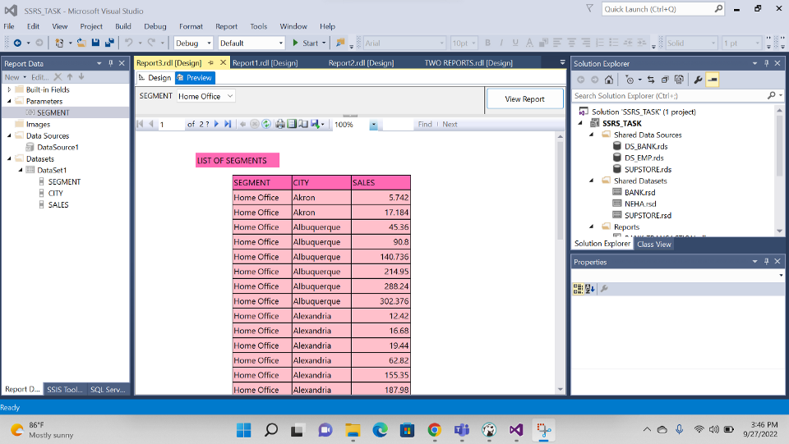

LIST OF SEGMENTS

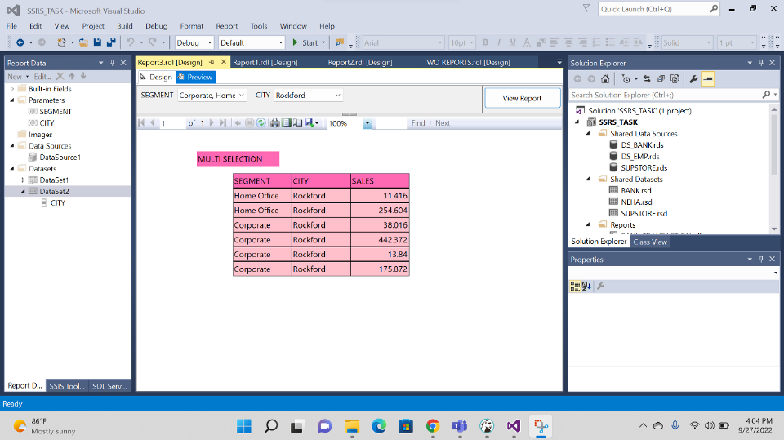

MULTI SELECTION

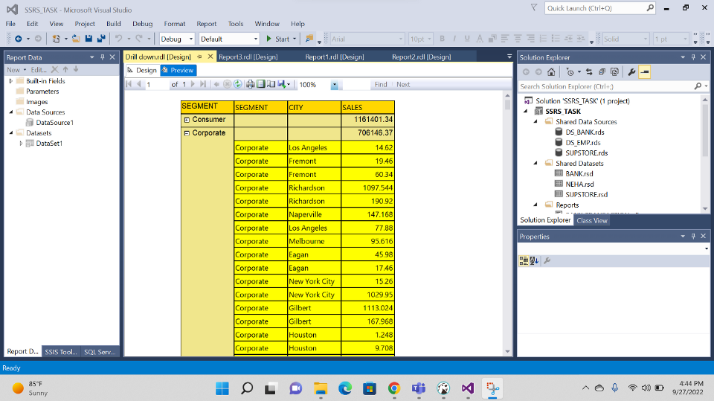

DRILL DOWN